File Integrity Monitoring:
File Integrity Monitoring is to monitor any changes to the file like creating, modifying and deleting file in the root directory.
What we will do?
We will create a file in Ubuntu and Windows and then do some modifications in it. After then we’ll see if we can see events generated by modifying file in the agents.

FIM on Ubuntu:
- Click on the Ubuntu agent > File Integrity Monitoring > Events
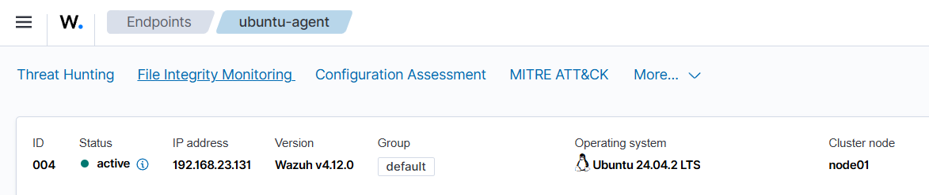
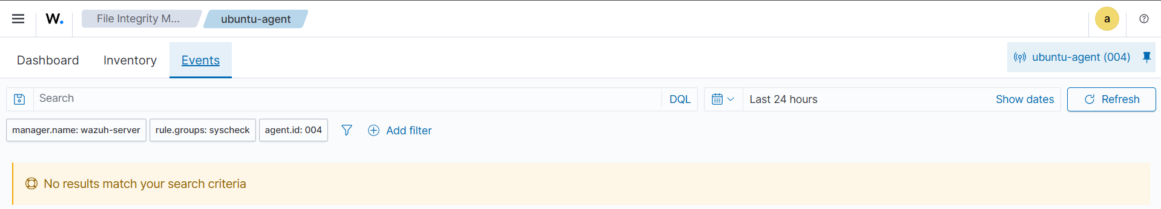

- We can see that we do not have any event/alerts yet

Let’s go to the Ubuntu machine and create a directory and file
- Use this command:
sudo mkdir -p /opt/fim-demo (It will create a directory)
echo “start” | sudo tee /opt/fim-demo/watchme.txt (It will create file named watchme.txt and save the word start in it)
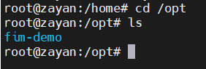
Basically, this command will first create a directory fim-demo and then save the word start in the file watchme.txt by creating it.
- Now open the configuration file by using this command
sudo nano /var/ossec/etc/ossec.conf
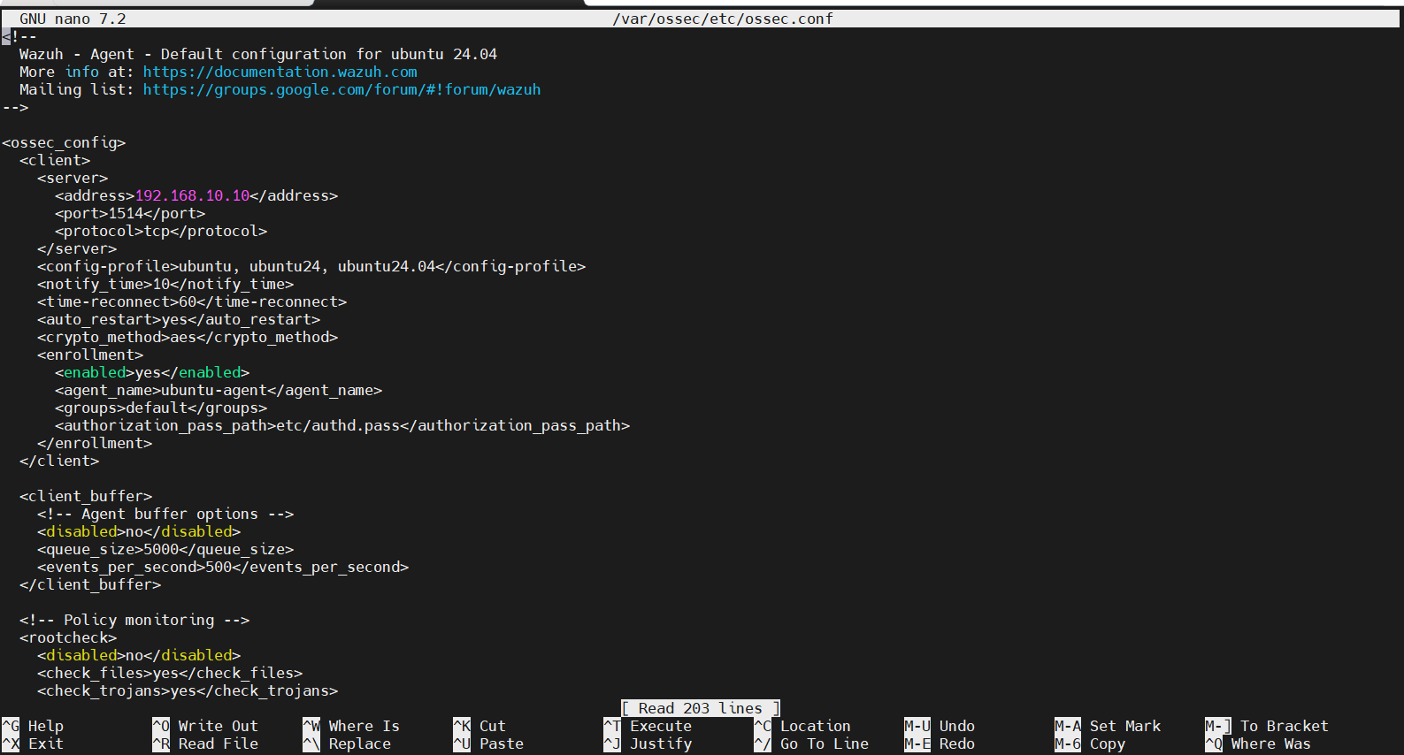
- Locate the <syscheck> block in this file and add this line in it
<directories realtime="yes" report_changes="yes">/opt/fim-demo</directories>
You can add multiple lines for multiple directories which you want to monitor
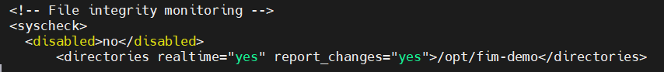
- Save the file and exit (CTRL + O > Enter > CTRL + X)
- Restart the Wazuh agent using this command
sudo systemctl restart wazuh-agent

- Use this command to test the changes in the file
echo "changed $(date)" | sudo tee -a /opt/fim-demo/watchme.txt
This command will add word changed with current date and save it to the watchme.txt file without overwriting the previous line.
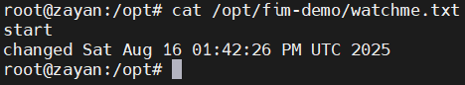
Now check events and dashboard and create or modify the logs.
- Go to the Ubuntu-agent in Wazuh > File Integrity Monitoring > Events
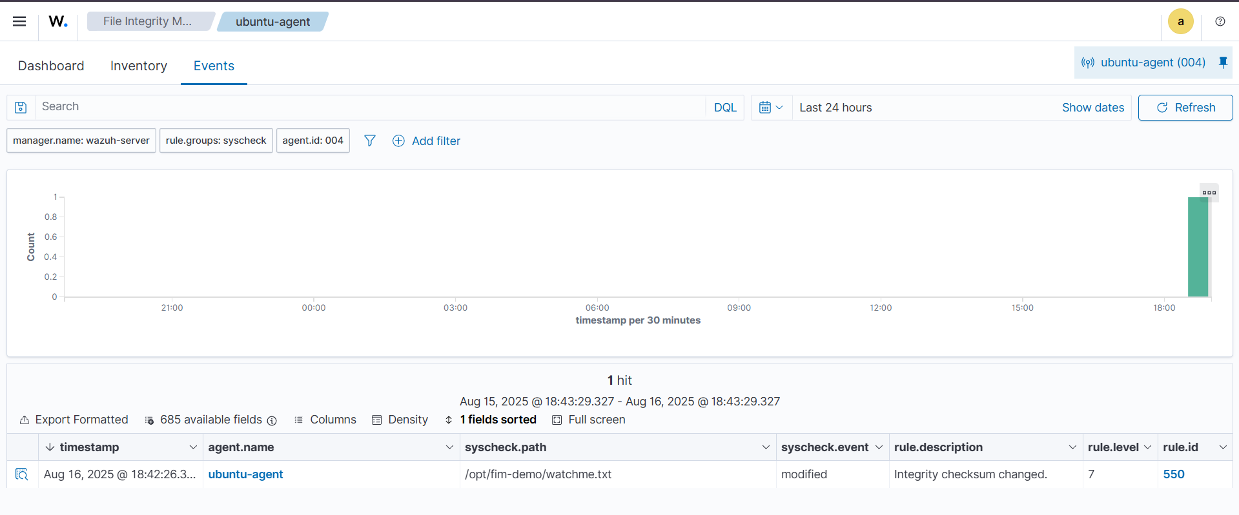
Now here we can see the events (what happened to our file etc.)
We can see everything like which file is modified (if we’ve added more paths or more directories), when it is modified and other details.
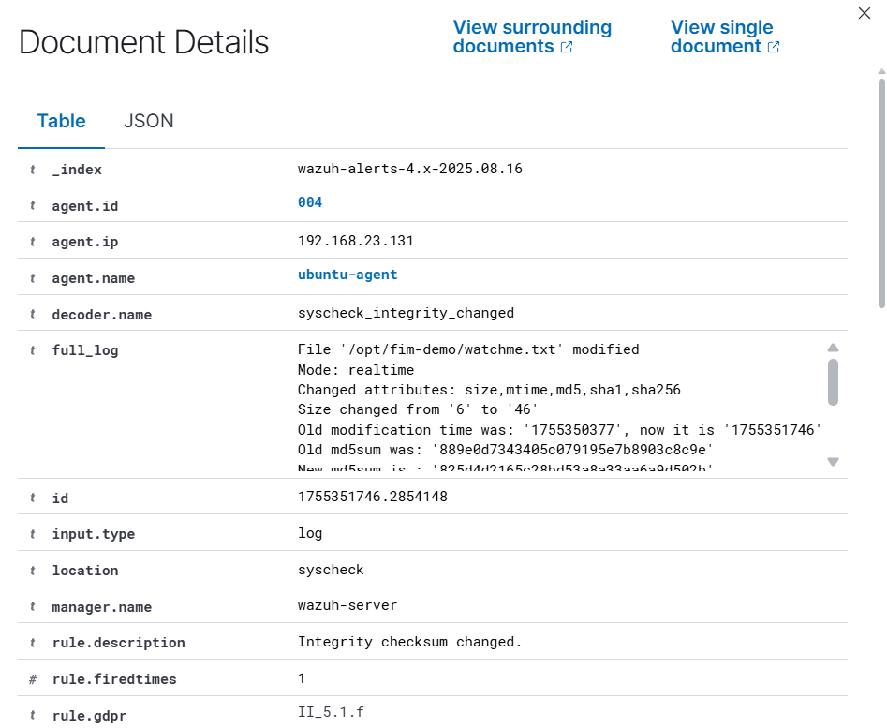
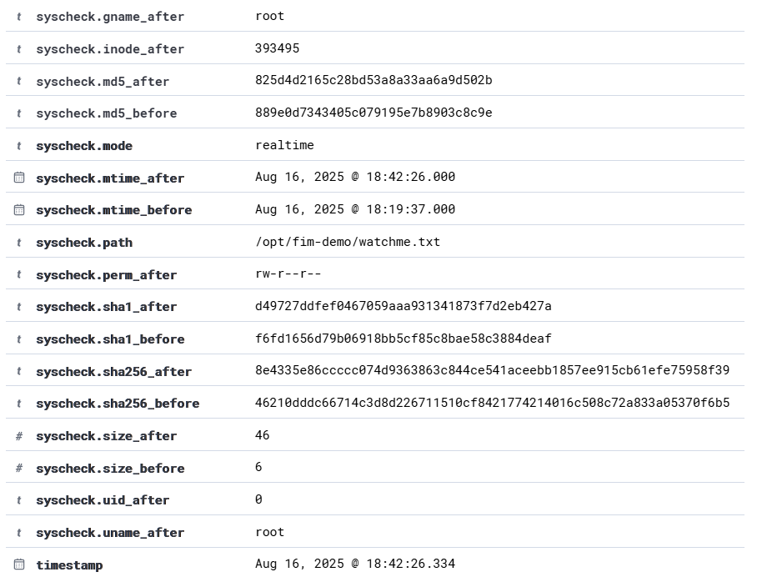

FIM on Windows:
Similarly, Go to your Windows machine
1. Create a test folder and file
- Open C:\ and create a new folder
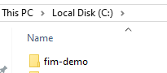
- Inside it, create a file watchme.txt and write some text (e.g., start).
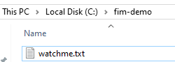
2. Edit the Wazuh agent configuration
- Open this file in Notepad as Administrator:
C:\Program Files (x86)\ossec-agent\ossec.conf
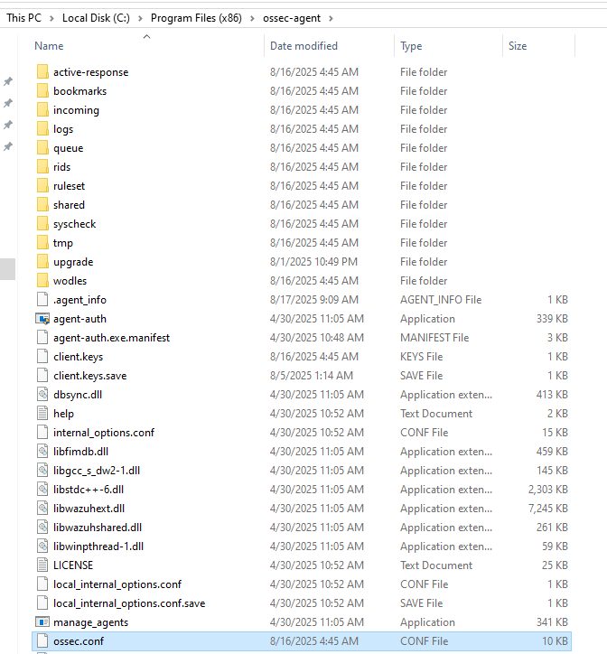
- Look for the <syscheck> block.
If it exists → add this line inside.
<directories realtime="yes" report_changes="yes">C:\fim-demo</directories>

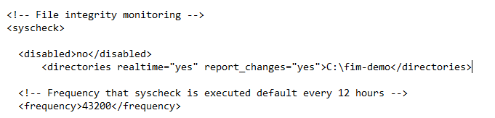
3. Restart the Windows Wazuh agent
- Open PowerShell (Run as Administrator) and restart the service:
Restart-Service -Name WazuhSvc
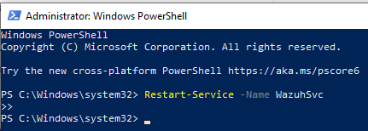
4. Test file monitoring
- Go to C:\fim-demo\watchme.txt
- Add or modify some text (e.g., Hi, My name is Muhammad Zayan)
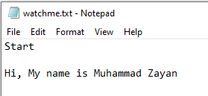
- Save the file
5. Verify in Wazuh Dashboard
- Navigate to File Integrity Monitoring → Events
You can see the events which happened to the file.
